Title: **The Labyrinth**

Team name: **Pico-a-Pico**

Team members:

* Leyteris Anastasovitis (CERTH)
* Panagiotis Migkotzidis (CERTH)
* Christina Tsita (CERTH)
* Alexandros Kyprianidis (AUTh)
* Petros Mitseas (AUTh)
* Marc Mueller (Goedle.io)

Concept idea: **The Labyrinth is an application that gamifies the myth of Theseus and the Minotaur**

[*Pasiphaë*](https://en.wikipedia.org/wiki/Pasipha%C3%AB)*, wife of King* [*Minos*](https://en.wikipedia.org/wiki/Minos) *of Crete, had several children. The eldest of these,* [*Androgeos*](https://en.wikipedia.org/wiki/Androgeos)*, set sail for Athens to take part in the* [*Panathenaic Games*](https://en.wikipedia.org/wiki/Panathenaic_Games)*, which were held there every four years. Being strong and skillful, he did very well, winning some events outright. He soon became a crowd favorite, much to the resentment of the Pallantides who assassinated him, incurring the wrath of Minos.*

*[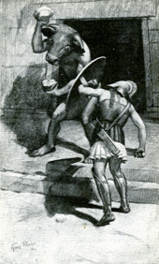](https://en.wikipedia.org/wiki/File:Theseus_and_the_Minotaur.gif)*

*Theseus and the Minotaur*

*When King Minos had heard of what befell his son, he ordered the Cretan fleet to set sail for Knossos. Minos asked Aegeus for his son's assassins, and if they were to be handed to him, the town would be spared. However, not knowing who the assassins were, King* [*Aegeus*](https://en.wikipedia.org/wiki/Aegeus) *surrendered the whole town to Minos' mercy. His retribution was that, at the end of every* [*Great Year*](https://en.wikipedia.org/wiki/Great_Year)*, which occurred after every seven cycles on the solar calendar, the seven most courageous youths and the seven most beautiful maidens were to board a boat and be sent as tribute to Crete, never to be seen again.*

*[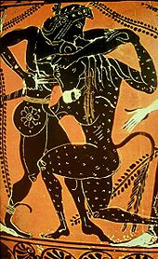](https://en.wikipedia.org/wiki/File:Minotaur.jpg)*

*Theseus and the Minotaur on 6th-century* [*black-figure pottery*](https://en.wikipedia.org/wiki/Black-figure_pottery)

*In another version, King Minos had waged war with the Athenians and was successful. He then demanded that, at nine-year intervals, seven Athenian boys and seven Athenian girls were to be sent to Crete to be devoured by the* [*Minotaur*](https://en.wikipedia.org/wiki/Minotaur)*, a half-man, half-bull monster that lived in the* [*Labyrinth*](https://en.wikipedia.org/wiki/Labyrinth) *created by* [*Daedalus*](https://en.wikipedia.org/wiki/Daedalus)*.*

*On the third occasion, Theseus volunteered to talk to the monster to stop this horror. He took the place of one of the youths and set off with a black sail, promising to his father,* [*Aegeus*](https://en.wikipedia.org/wiki/Aegeus)*, that if successful he would return with a white sail.*[*[10]*](https://en.wikipedia.org/wiki/Theseus#cite_note-10) *Like the others, Theseus was stripped of his weapons when they sailed. On his arrival in Crete,* [*Ariadne*](https://en.wikipedia.org/wiki/Ariadne)*, King Minos' daughter, fell in love with Theseus and, on the advice of Daedalus, gave him a ball of thread (a* [*clew*](https://en.wiktionary.org/wiki/clew)*), so he could find his way out of the Labyrinth.*[*[11]*](https://en.wikipedia.org/wiki/Theseus#cite_note-11) *That night, Ariadne escorted Theseus to the Labyrinth, and Theseus promised that if he returned from the Labyrinth he would take Ariadne with him. As soon as Theseus entered the Labyrinth, he tied one end of the ball of string to the door post and brandished his sword which he had kept hidden from the guards inside his tunic. Theseus followed Daedalus' instructions given to Ariadne; go forwards, always down and never left or right. Theseus came to the heart of the Labyrinth and also upon the sleeping Minotaur. The beast awoke and a tremendous fight then occurred. Theseus overpowered the Minotaur with his strength and stabbed the beast in the throat with his sword (according to one* [*scholium*](https://en.wikipedia.org/wiki/Scholium) *on Pindar's Fifth Nemean Ode, Theseus strangled it).*[*[12]*](https://en.wikipedia.org/wiki/Theseus#cite_note-12)

*After decapitating the beast, Theseus used the string to escape the Labyrinth and managed to escape with all of the young Athenians and Ariadne as well as her younger sister* [*Phaedra*](https://en.wikipedia.org/wiki/Phaedra_(mythology))*. Then he and the rest of the crew fell asleep on the beach of the island of Naxos, where they stopped on their way back, looking for water. Athena woke Theseus and told him to leave early that morning and to leave Ariadne there for Dionysus, for Naxos was his island. Stricken with distress, Theseus forgot to put up the white sails instead of the black ones, so his father, the king, believing he was dead, committed suicide, throwing himself off a cliff of Sounio and into the sea, thus causing this body of water to be named Aegean Sea.* [*Dionysus*](https://en.wikipedia.org/wiki/Dionysus) *later saw Ariadne crying out for Theseus and took pity on her and married her. (*

*Wikipedia:* [*https://en.wikipedia.org/wiki/Theseus#Theseus_and_the_Minotaur*](https://en.wikipedia.org/wiki/Theseus#Theseus_and_the_Minotaur)

Technology used:

* 3D game engine: **Unity3D**
* 3D graphics design: **Maxon Cinema4D**
* 2D graphics design: **Adobe Photoshop**
* Game Analytics:
  + - NoSQL database: **restdb**
  + – processing tracking data: **python**
  + – visualization: python **matplotlib**
  + - Unity SDK: **C#**
* Other resources:
  + Sound clips: downloaded from [www.freesound.com](http://www.freesound.com)
  + Bullhead’s 3D model: downloaded from <https://www.thingiverse.com/thing:1631572>

AI used: In the game there are two agents, Minotaur and Theseus. The first one is patrolling the maze by following specific landmarks placed inside the maze. In order to achieve that, we use Unity's built-in pathfinding system which utilizes the A* algorithm to find the optimal route to each landmark. The second is a Reinforcement Learning agent implemented from scratch. The algorithm used is DYNA-Q, which is essentially model-based tabular Q-Learning. The goal of the RL agent is to find the best possible route leading to the exit of the maze.

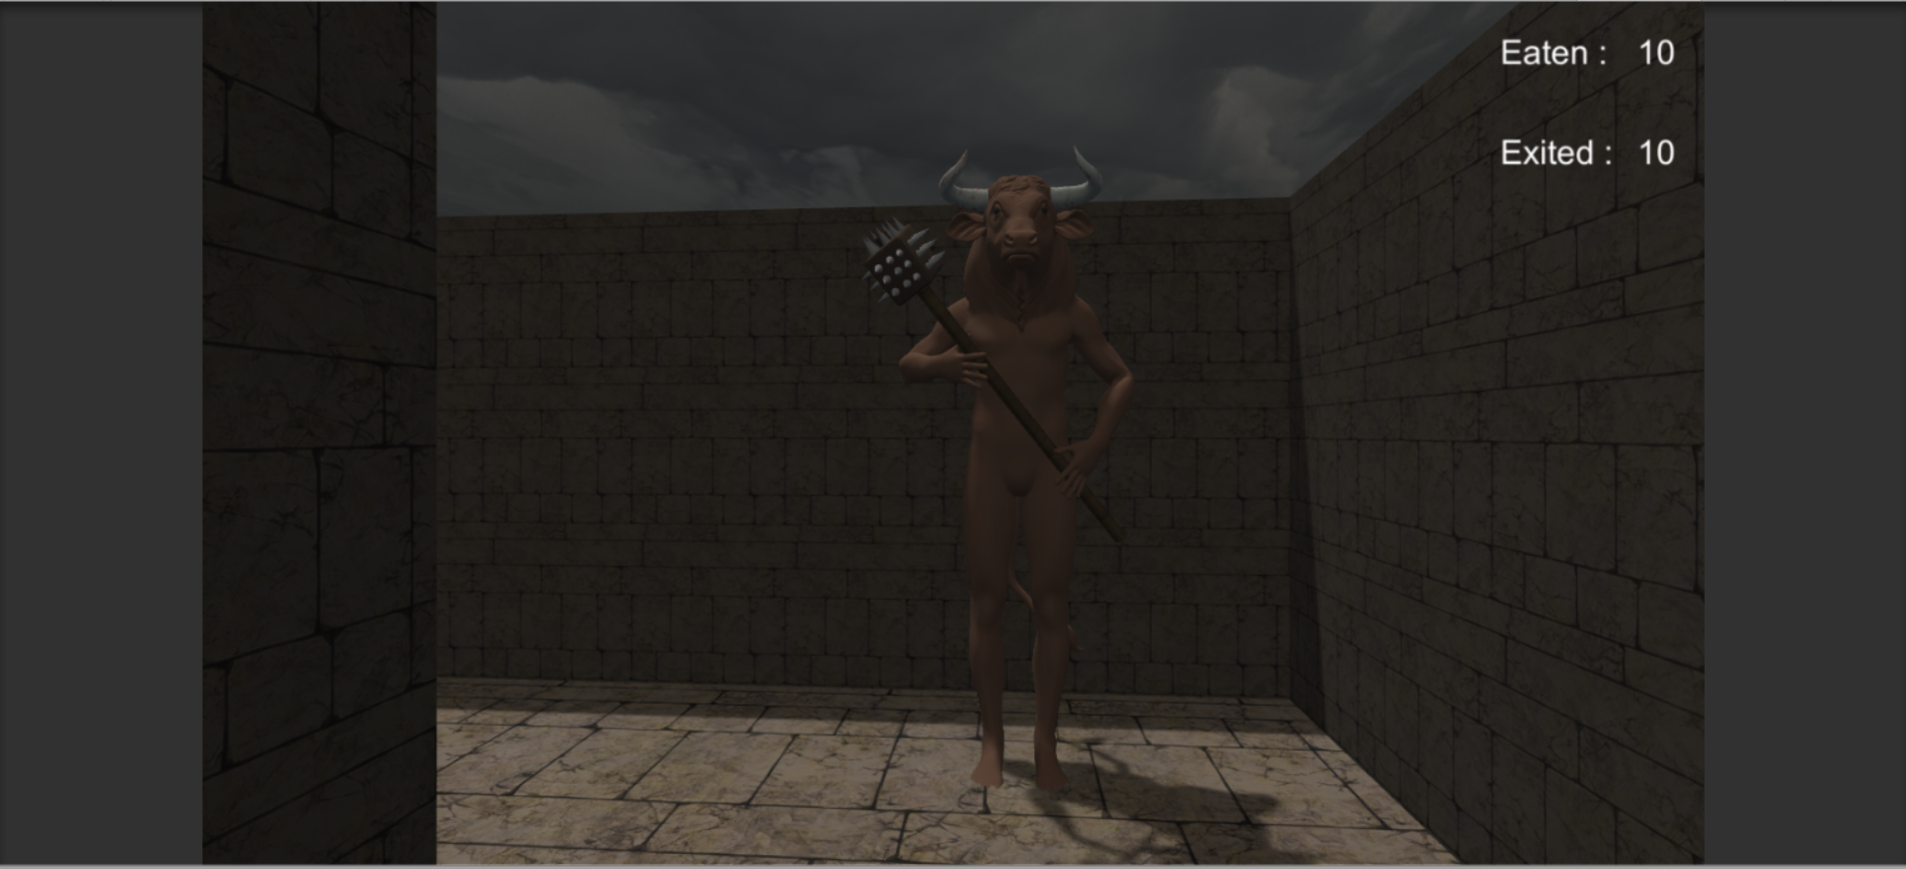

Minotaur in-game

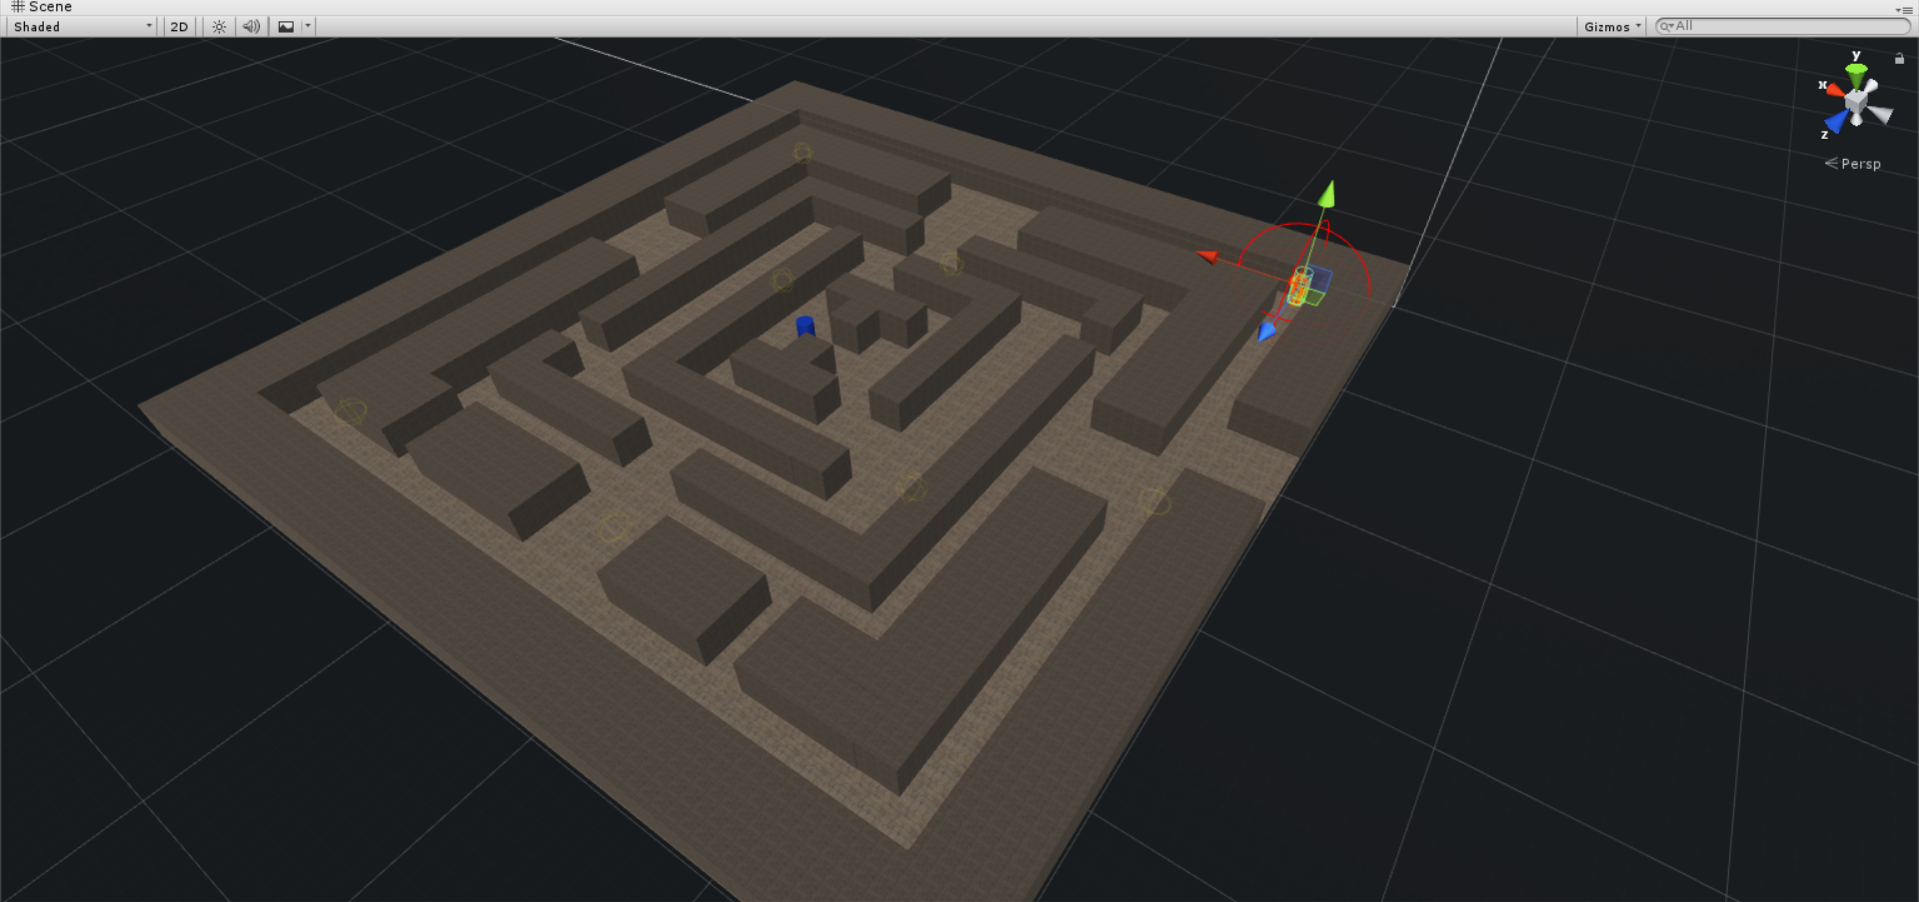

Mace with Minotaur and Theseus

Analytics used: We used a no SQL database to store in-game tacking data.

The data is sent via a slim unity SDK that sends every 5 seconds the location of both agents.

To visualize the agent’s behavior data is transferred to a space-time cube. The space-time cube is created in real time and can show the actual behavior of the agents when running the game.

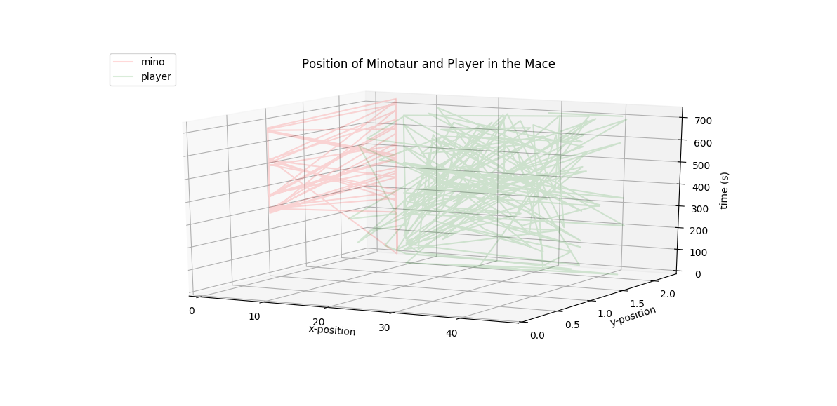

Movement of both agents, green (Theseus), red (Minotaur)